# Title:

**“**Watershed and oceanic controls on spatial and temporal patterns of sediment accumulation in a fringing reef flat embayment”

# Outline:

*Goal for the manuscript:*

Use measurements/models of sediment loading and hydrodynamic forcing to interpret temporal and spatial patterns of sediment accumulation.

*Motivation:*

“It is evident that the understanding of fine-grained terrestrial sediment plume transport, deposition, reworking, and advection out of coral reefs is key to helping establish monitoring programs to determine the effectiveness of land-based watershed restoration conducted to support coral reef ecosystem health.” (Storlazzi et al. 2015)

## INTRODUCTION

**Background of the problem:**

* Processes sediment affects corals:
  + Light attenuation
    - Higher concentrations, finer grain sizes and darker grain colors more effectively reduce PAR (Storlazzi et al. 2015)
    - Finer grains also remain suspended for longer (low settling velocity, low resuspension threshold) -> more exposure (duration x intensity)
  + Sediment accumulation is ultimate light attenuator
    - Also has weird biological process with cell breakdown (Weber et al. 2012)
    - Finer, more organic is worse than coarser coralline (Weber et al. 2012)
    - Expend energy to get rid of sedimentation
  + Others
    - Interfere with spawning?
    - Reduces sites for larval recruitment
    - Reduces herbivory of algae, which stabilizes shift to algae-dominated system and then fish leave because no algae (Bellwood and Fulton 2008; Goatley and Bellwood 2012; Clausing et al. 2014)
* Complex sediment sources and hydrodynamics control sediment dynamics, which control coral health
  + Sedimentation linked to watershed input but hydrodynamics can limit by prevention and resuspension (Hoitink and Hoekstra 2003; Storlazzi et al. 2009)
  + Sediment accumulation in tropics is controlled by interplay of sediment input from floods and flushing by wave events, which are not always in sync (Draut et al. 2009)
    - different than “oceanic storms” in temperate zones (Warrick et al. 2004; Bever et al. 2011)
  + Given watershed disturbance, an integrated understanding of sediment from source to reef is needed
* Linking watershed inputs to sediment accumulation
  + Correlate with storms/floods: larger sediment input -> more sediment accumulation (Draut et al. 2009; Gray et al. 2012) and probably even more
* Measuring sedimentation in the short term: physical methods and interpretation
  + In contrast to geological time scale methods like sediment cores etc (Brooks et al. 2007)
  + Biological vs Physical methods for measuring sediment accumulation:
    - Bio
    - sediment impact inferred from coral health metrics like % cover
    - bio-indicators like gene-expression or incorporation into coral skeleton (Fallon et al. 2002; Downs et al. 2012; Rotmann and Thomas 2012) and probably lots of others
    - physical
    - related: measuring water column SSC with turbidimeters or grab samples (Wolanski et al. 2003)
    - sediment measured in tubes (White 1990)
    - sediment measured on pods/tubes (Field et al. 2012) but few have combined except for (Gray et al. 2012); rotating tube traps (Storlazzi et al. 2009)
    - cameras? (Storlazzi et al. 2009) Short term but don’t measure composition but can infer from color
    - future? Light attenuation or upward looking turbidimeters? (Thomas and Ridd 2005);
  + (Storlazzi et al. 2015): “it is necessary to specifically measure sediment grain size and composition collected using different tools and techniques (e.g., Storlazzi et al. 2011; Field et al. 2012) during experiments or monitoring programs established to monitor coral reef health or the effectiveness of restoration efforts.”
  + Discontinuous vs Quasi-continuous methods for short-term measurement of sediment accumulation (Thomas and Ridd 2004)
  + Tube traps most common but maybe not relevant indicator? SedPods way forward? (Storlazzi et al. 2011; Field et al. 2012)
* Thought: given the flow pattern observed in paper 2, could hydrodynamic conditions continue to exacerbate effects instead of flushing???

Examples of such studies include Storlazzi et al. (2004) and Presto et al. (2006) on the fringing reef of southern Molokai, Hawaii; Orpin et al. (1999) in the Great Barrier Reef lagoon; and Hoitink and Hoekstra (2003) in Indonesia. Collectively, results from these investigations show that fine sediments can be suspended under fair-weather conditions on reefs and in lagoons, net transport is a function of net current direction, fine sediments are effectively flushed from high-energy reef settings but aggregate in lower energy reef and lagoon environments, and that the orientation of the coast with respect to prevailing winds and waves is an important determinant on whether sediment is trapped or flushed from a reef system.

Furthermore, as noted earlier, mechanically derived size distributions do not reflect the hydrodynamic characteristics of heterogeneous carbonate deposits. –so can’t interpret fine/coarse in relation to hydrodynamic bc carbonates movement is altered strongly by shape and density, not just size

The major process controls on the formation and stability of reef sedimentary landforms are sediment supply and oceanographic regime. Wave

–Kench encycl. Entry Hopley 2011

“Turbid-zone reef” or “Terrigenous sediment-influenced reef”

Corals can cope with large changes in fluvial sediment supply so hard to infer changes in sediment from coral. If they aren’t changing then so what, they’re coping with it. Have to identify coral are stressed by sediment.

-Perry encycl. Entry

Sediment decreases herbivory of algal turf (Bellwood and Fulton 2008) across coral reef depth gradient (Goatley and Bellwood 2012), and increased algal height can increase sediment trapping. Sediment can also decrease the growth of epilithic algae by developing black basal sediment layers high in hydrogen sulfide (Clausing et al. 2014), similar to the necrotic effects on corals (Weber et al. 2012). Under moderate sedimentation or high energy hydrodynamic conditions, herbivory can maintain short, healthy algal communities, but in slow-moving waters with high organic, terrigenous sediment the anoxic black basal layers are more common at shallower sediment depths (Clausing et al. 2014).

**Specific knowledge gap:**

Faga’alu is exposed to enhanced sediment input, hydrodynamics are heterogeneous, so where and when is sediment accumulation occurring?

**So we did “X” to learn “Y”:**

We monitored sediment input and modeled residence time over the reef, and monitored sediment accumulation in tubes and SedPods to determine:

1. What are the spatial patterns of terrigenous and coralline sediment accumulation?
2. What are the temporal patterns of terrigenous and coralline sediment accumulation?

At each site? Over the northern and southern reefs?

1. How do flood-supplied terrigenous sediment and hydrodynamic conditions interact to control the gross and net rate of terrigenous sediment deposition at monthly time scales in a coral reef embayment?

## MATERIALS AND METHODS

### Study Area

* Location, size, layout, depths, physical and biological characteristics of reef
* Description of seasonality and prevailing waves, winds, and tides
* Flood plume dynamics from Faga’alu Stream to Faga’alu Reef, and referring to other papers in Faga’alu
* Figure 2. Flood plume pictures in the bay
* Previous studies/data: Sabater unpubplished, Pilot study??
* Other on-going work includes sediment yield monitoring from watershed, sediment accumulation on the reef, and larger restoration efforts of USCRTF

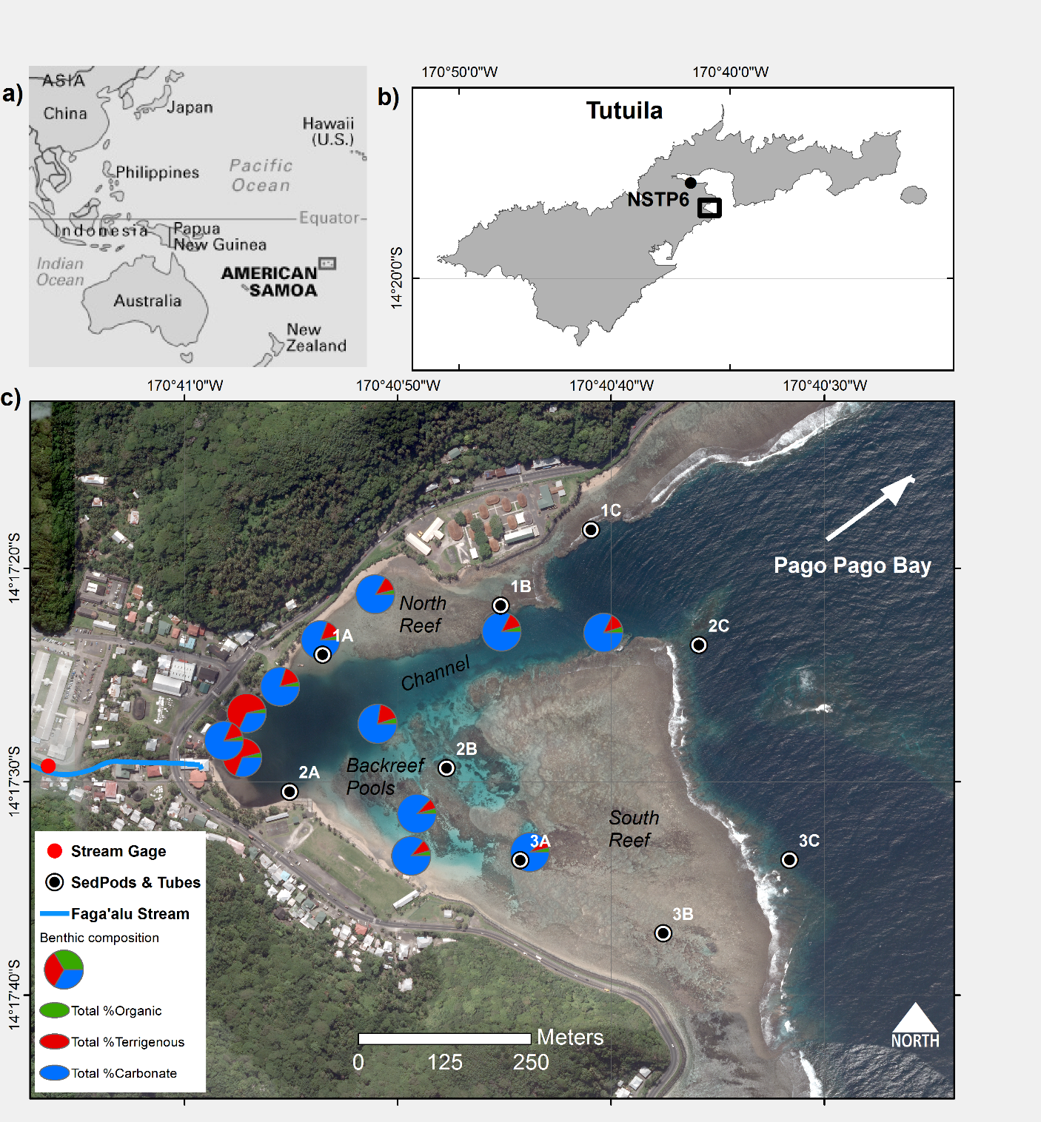

Figure 1. Study area

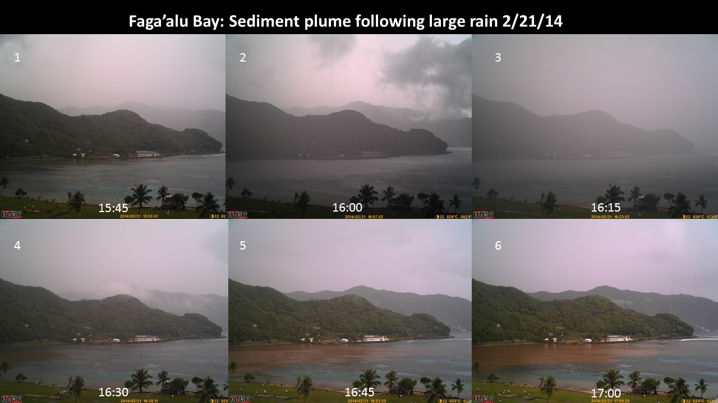

Figure 2. Time series of sediment plume following a brief but intense rainfall



Figure 3. Pictures of the sediment tube traps and SedPods. a-b) At Site 3A in an area of branching coral rubble, approx.. depth 2m c) Capping the SedPod for retrieval at Site 1C, approx. 10m depth d) At Site 1B, the surrounding area is mixed terrigenous and carbonate benthic sediment.

### Methods

O*utline the methods used*

**Meteorological and oceanic forcing**

* WW3 data
* How processed?
  + Mean Monthly Significant Wave Height
  + (Seymour 2011; Rangel-Buitrago et al. 2014)

**Sediment input**

* Measured and predicted
* Different models for pre- and post-mitigation periods

**Tubes**

* 30 cm long with an internal diameter of 5 cm; mounted on the side of a cinder block with the SedPod
* (Bothner et al. 2006) found co-located Tubes differed by 11% on average
* The average daily collection rate was calculated by measuring the total mass of sediment in the tube or on the pod, and dividing by the trap cross-sectional area and the duration of collection period (Storlazzi et al. 2009)

**SedPods**

* 10cm tall by 15.5 cm diameter; mounted on cinder block

**Residence time of sediment?**

**Analytical methods**

In the laboratory, sediments accumulated in the sediment-trap tubes and on the SedPods was analyzed for grain size and composition. Sediment grain size analysis was conducted by wet-sieving the bulk sediment sample into coarse (2mm to 63 um) and fine fractions (<63 um)((Storlazzi et al. 2009) says “sand” and “mud”). Coarse and fine fractions were filtered onto 3 um filter paper, rinsed with distilled water, and dried. Coarse and fine fractions were analyzed separately for sediment composition, using the Loss On Ignition method (combusting 3 hours at 550 C for % organic; 950 C for 3 hours for % carbonate)(Heiri et al. 2001). The proportion (%) of terrigenous sediment was then determined by subtraction from the % organic and % carbonate and multiplied by the sediment accumulation rate to get the rate of terrigenous sediment accumulation in the trap tubes (Gray et al. 2012).

## RESULTS

*Results are the data - not methods. You can compare the results to other studies to put them in context, but don't explain why you think you're seeing the patterns you're seeing - that's for the Discussion.*

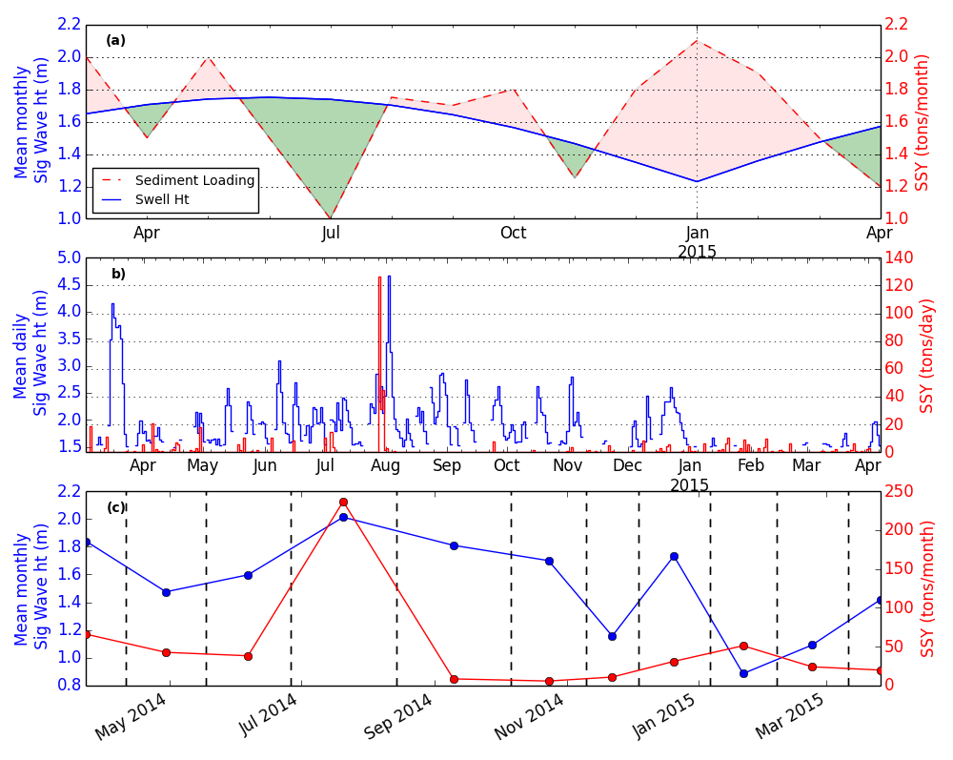

Figure 4. Conceptual model of net sediment accumulation driven by interacting sediment input and wave-forced sediment removal

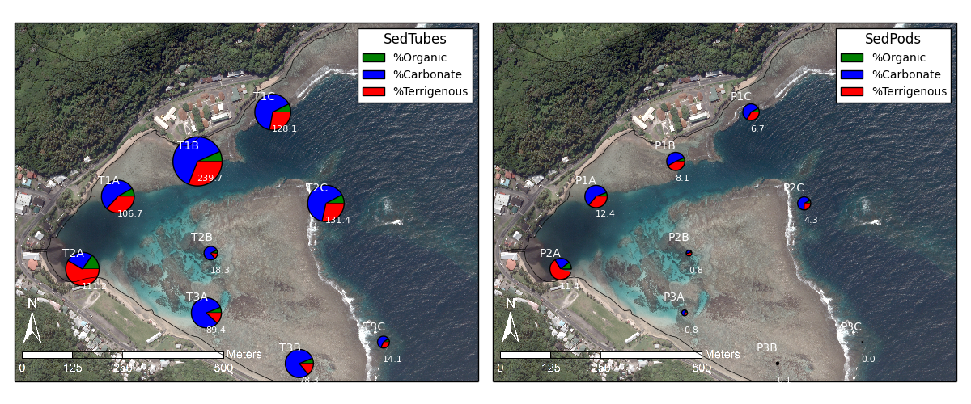

Figure 5. Mean accumulation rate (gm2d) and composition in a) Tubes and b) SedPods. Note: Subplot scales are different for visualization purposes, can’t compare sizes of charts, hence numbers included.

Mean terrig/Mean Total, Mean Org/Mean Total, Mean carb/Mean Total, NOT just mean percent Terrig * Mean total

Clear spatial pattern of higher terrigenous accumulation on the Northern reef and Channel including 2C. South Reef dominated by carbonate accumulation while North reef showed significant contributions of Terr/Org. Much more accumulation in Tubes than on Pods; on the Southern reef, almost no accumulation on Pods while Tubes showed a fair amount of accumulation. Three A,B probably influenced by local sources and resuspension due to higher waves and shallower water, while 2B was low due to surrounding coral cover.

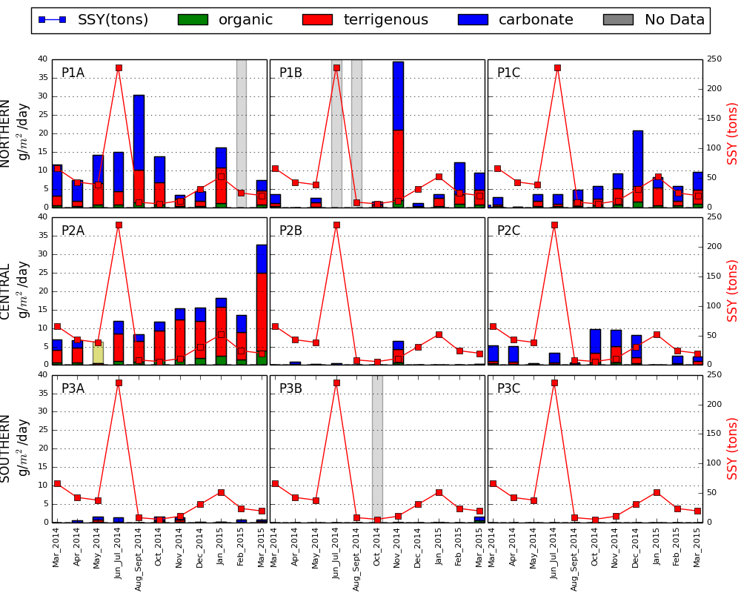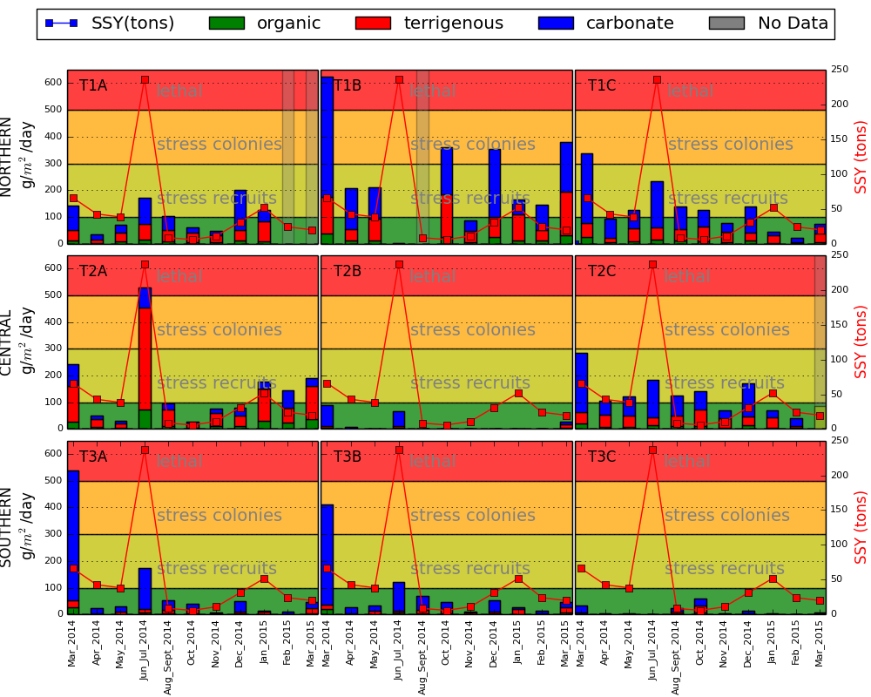

## DISCUSSION

*The Discussion is where you first discuss how well the Lagrangian and Eulerian methods compare, then characterize the findings by the different types of forcing and why you think you're seeing these patterns you see in the data. You then can discuss the relevance to residence times and what they mean for sediment, nutrient uptake, etc.*

Kench 1998 showed at narrow, energetic part of reef there was bioclastic sediment mobility under fair-weather conditions; may be happening at 3A and B

Bothner 2006 found trap collection was higher following rainfall events but not always and not linearly related

Coral Health Thresholds

Pastorok and Bilyard (1985) suggested that sediment accumulation rates of 10-50 mg/cm2/day and > 50 mg/cm2/day cause “moderate to severe” and “severe to catastrophic” sediment stress, respectively. High sedimentation rates (>100 mg/cm2/day) have also been shown to kill exposed coral tissue (Riegl and Branch 1995) or reduce photosynthetic yields (Philipp and Fabricius 2003).

*Wrap it all up with the big take-away message* *No Conclusion in “Coral Reefs”, give big take-away message*

**Take-away message**